

**Name**:

Usama Iftikhar Butt

**Roll No.:**

Roll no

Assignment No. 1 (Lab)

**Program to Print Sum and Average in the Array.**

#include "stdafx.h"

#include "iostream"

using namespace std;

void main() {

int const L = 10;

int Array[L] = { 0, 1, 2, 3, 4, 5, 6, 7, 8, 9 };

int Sum = 0;

for (int i = 0; i < L; i++) {

Sum += Array[i];

}

cout << "Sum is : " << Sum << endl;

cout << "Average is : " << Sum / L << endl << endl;

}

Output:

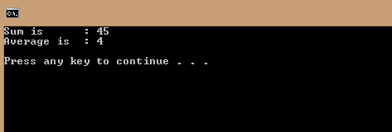

Program to find the Minimum and Maximum in Array.

#include "stdafx.h"

#include "iostream"

using namespace std;

void main() {

int const L = 10;

int Array[L] = { 0, 1, 2, 3, 4, 5, 6, 7, 8, 9 };

int Max = Array[0], Min = Array[0];

for (int i = 0; i < L; i++) {

if (Array[i] < Min)

Min = Array[i];

if (Array[i] > Max)

Max = Array[i];

}

cout << "Max : " << Max << endl;

cout << "Min : " << Min << endl << endl;

}

Output

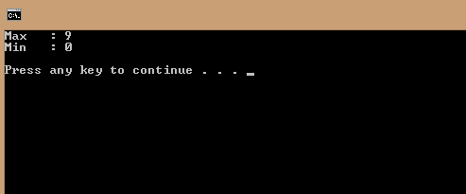

Program to store Square of elements of Array in another Array

#include "stdafx.h"

#include "iostream"

using namespace std;

void main() {

int Array[10] = { 0, 1, 2, 3, 4, 5, 6, 7, 8, 9 };

int Square[10];

cout << "Final Squared Array is : ";

for (int i = 0; i < 10; i++) {

Square[i] = Array[i] * Array[i];

cout << Square[i] << ", ";

}

cout << endl;

}

Output:

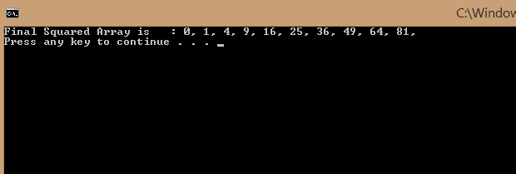

Program to enter data in specific location in Array

#include "stdafx.h"

#include "iostream"

using namespace std;

void main() {

int const L = 10;

int Array[L];

int Index, Length = 0, Option;

do{

cout << endl << endl;

cout << "To enter Data : 1" << endl;

cout << "To Display Array : 2" << endl;

cout << "To Exit : 0" << endl;

cout << "Enter Option : ";

cin >> Option;

cout << endl << endl;

if (Option == 1) {

if (Length != 10) {

do

{

cout << "LENGTH of ARRAY is " << Length << endl << "Enter Index to set value : ";

cin >> Index;

} while (Index > Length);

for (int i = Length; i > Index; i--)

//To shift the data to right

Array[i] = Array[i - 1];

Length++;

cout << "Enter Data to Store : ";

cin >> Array[Index]; //Input data from user

}

else

cout << "Sorry! Array is full.";

}

else if (Option == 2) {

cout << endl << endl << "The Array is :";

for (int i = 0; i < Length; i++) //Display Array

cout << Array[i] << ", ";

}

} while (Option != 0);

}

Output:

